**VC dimension:**

It’s used to find how much powerful is a class of models for theoretical proof, it’s not use in practical or applied ml. isliye jada dimag mat lagana.

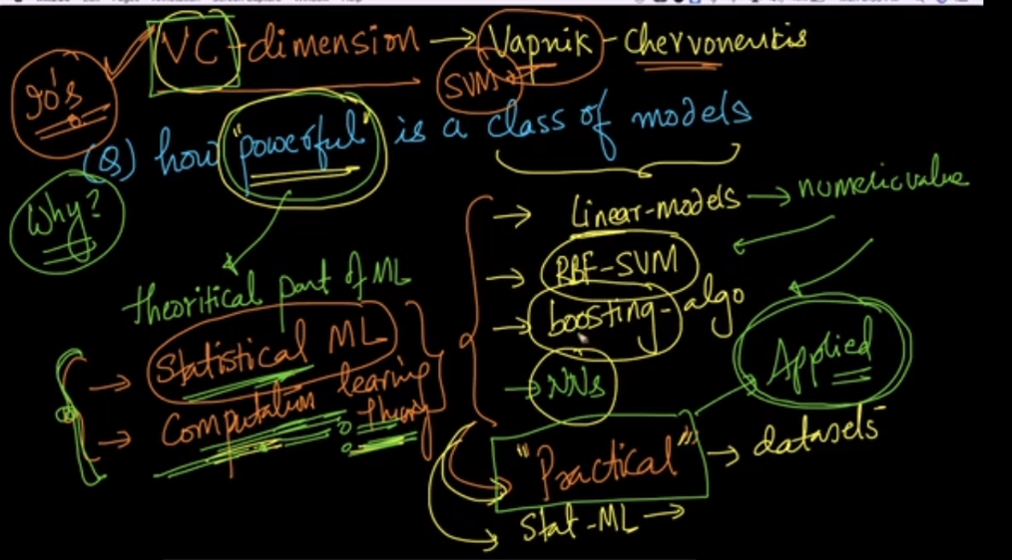

let’s see VC-dim for linear models.

Lets say there are only 2 points, 1 +Ve and 1 –ve, now both the points can be separated/shatterd in any of the configuration.

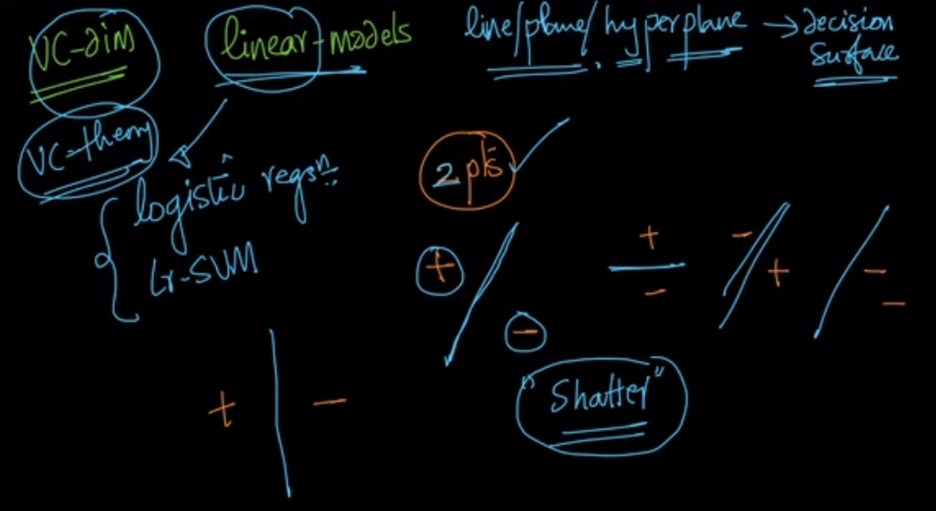

Let’s take 3 points, we can see that 3 points can also be shattered in any of the configuration.

Let’s take 4 points, we can see that 4 points, can’t be shattered in one configuration as given below.

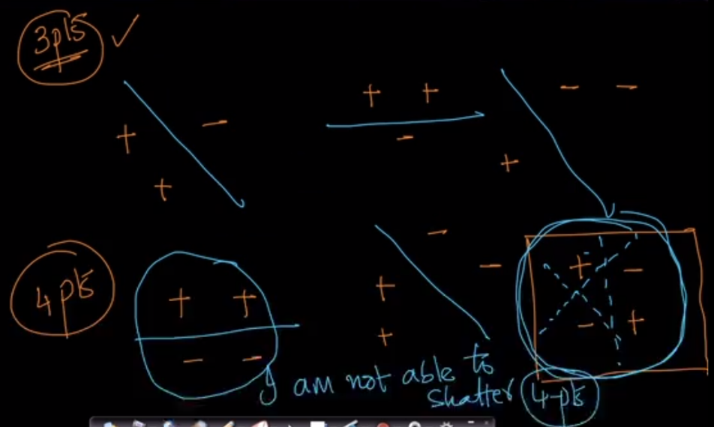

Since here there is at least one configuration of 4 points, that can’t be shattered, therefore we’ll say that VC dim of linear model as 3 which is max no. of points that can be shattered by a linear model for all possible config.

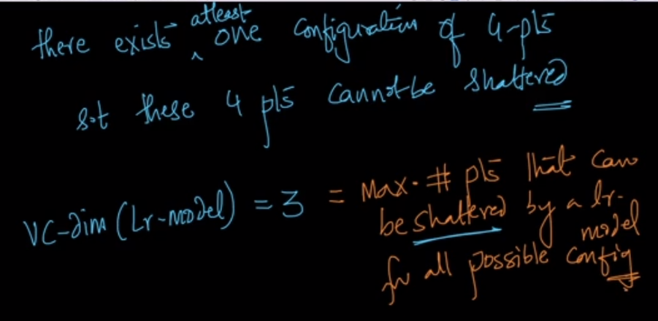

To find a vc dim of boosting classfier there is a formula.

For a given model B, whose vc dimension is D and we have used T such models then its VC dimension is given in below image.

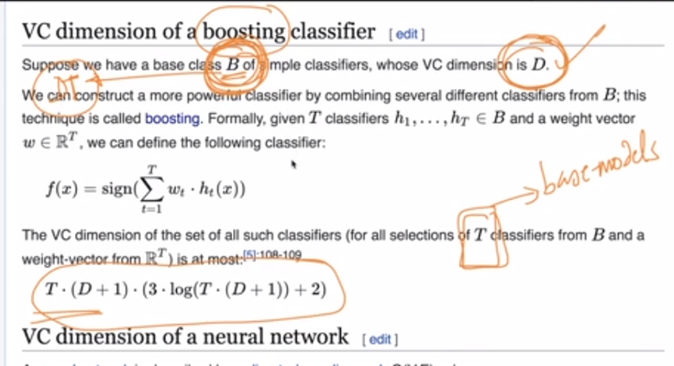

Now if VC dim of any model is best therrotically then it doesn’t mean that it’s best model in practice, because there are several assumptions made in order to find the VD dimension.

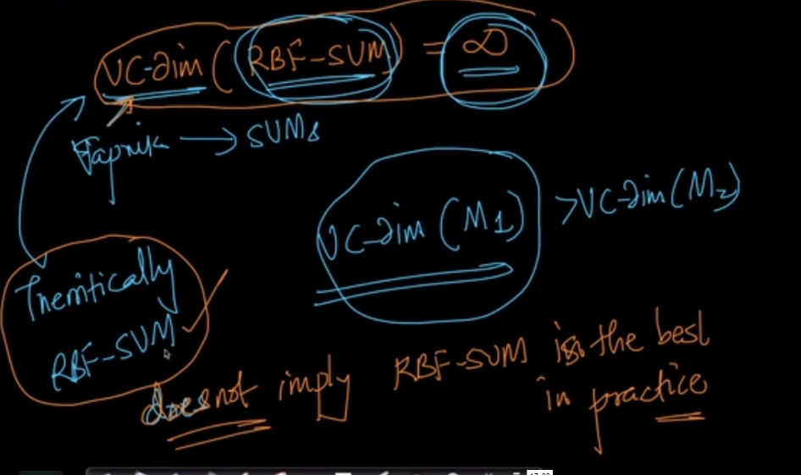

Formula to find probability that test error is less than train error + some constant.

